COMPSCI 383 – Spring 2026
Homework 1 Primer
Due Thursday, February 19th at 11:59pm ET

You are encouraged to discuss the assignment in general with your classmates, and may optionally collaborate closely with one other student. If you choose to do so, you must indicate with whom you worked. Multiple teams (or non-partnered students) submitting the same solutions will be considered plagiarism. The use of AI code generators (e.g. ChatGPT, Copilot) is prohibited.

Understanding Search Basics
This assignment is intended to help you build some intuition for how different search strategies work, what their strengths and weaknesses are, and what types of things we can or cannot guarantee about their behavior.

Grading
We will grade your answers based on whether they demonstrate an understanding of the concepts in each question. Some questions have more than one correct answer. We will award partial credit for answers that show partial understanding.

What to Submit
You should submit a modified version of this file containing your answers to the questions. The first three pages are for recording your answers, the fourth page is for showing any work.

Answer the following questions (1-3 sentences) in the space provided:

- If every state has b successors, and the goal state is at depth d, what is the upper limit on the number of states Breadth-first search needs to add to its frontier?
- Uniform-cost search is optimal, but Greedy best-first search is not. Given that both have exponential time complexity, why would you ever use Greedy?
- Which properties of A* (if any) are violated if the heuristic used is not admissible and consistent?

- If h(s) = 0 for all states s, is h admissible? What other search strategy that will behave the same as A* paired with h?

- Given two admissible heuristics, h1(s) and h2(s), if h1(s) > h2(s) for all s, which heuristic will perform better? Why?

- Explain why storing the frontier or explored states in a standard Python list is a bad idea for any best-first search (Uniform-cost, Greedy best-first, A*).

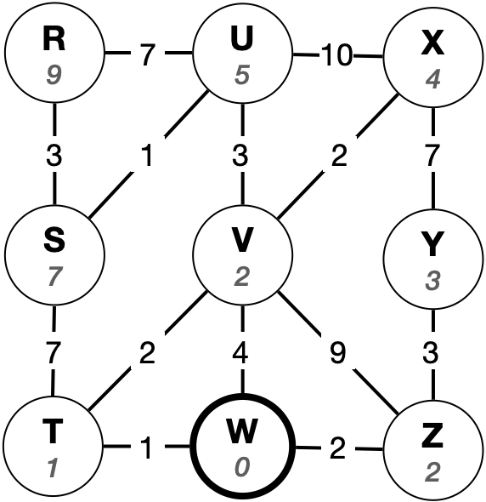
- The graph on the right represents a state space with states (nodes) R-Z. Possible transitions between states are represented by the edges in the graph, and numbers along the edges show the cost of each transition. The numbers inside the circles indicate the value of an admissible and consistent heuristic function that estimates the path cost to state W.
Consider a (graph-based) search with start state R and goal state W. For each of the following search strategies, indicate the order that the states will be popped from the frontier data structure and expanded, along with the solution path that will be returned. Show your work on the next page.
  - Breadth-first search
Pop order: ______________________________________________
Solution: ______________________________________________

  - Uniform-cost search
Pop order: ______________________________________________
Solution: ______________________________________________

  - Greedy best-first search
Pop order: ______________________________________________
Solution: ______________________________________________
  - A* search
Pop order: ______________________________________________
Solution: ______________________________________________

Show your work for Question 7 here:

